Energy Consumption and Global Warming

Middle School Unit

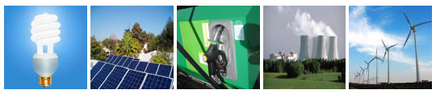

(Hui Jin, Lindsey Mohan, Jonathon Schramm, Li Zhan, Charles Anderson)
Environmental Literacy Project
Michigan State University
January 2009

CONTENT

overview 3
ACTIVITY 1. Where DOES CARBON DIOXIDE go? 9
ACTIVITY 2. Electricity generation 15
Activity 3: power plants 19
activity 4: Where do fossil fuels come from? 26
activity 5: Connecting processes 32
ACTIVITY 6. CARBON CYCLING (2 DAYS) 37
ACTIVITY 7: CArbon FOOTPRINT (3 DAYS) 47

Name:__________________________ Period/Hour:________

WHERE DOES CARBON DIOXIDE GO?

1. There are four events below: Trees Growing in the Amazon Forest; Cars Running on Highway; Girl Running; Burning Propane to Cook. For each event think about how the event changes matter and how it changes energy. Use the process tool to analyze each event.
Trees Growing in Amazon Forest

Matter Input
Matter Output
Energy Output
Energy Input

Cars Running on Highway

Matter Input
Matter Output
Energy Output
Energy Input
Girl Running

Matter Input
Matter Output
Energy Output
Energy Input

Using Propane to Cook

Matter Input
Matter Output
Energy Output
Energy Input

2. Out of the four events, three events are alike and one is different. Which event is different from the others?

3. For the three events that are alike, what do they have in common in the way the event transforms matter? What is in common in the way they transform energy?

4. For the event that is different from the other three events, how is it different in the way it transforms matter? How is it different in the way it transforms energy?

5. Which event(s) emit carbon into the atmosphere? Which event(s) remove carbon from the atmosphere?

6. You have looked at four common events we see in our everyday lives and learned how those events change matter and energy. Now think about what happens when we turn on appliances in our homes. The event below shows a lamp being turned on at night. Use the process tool to show how this event changes matter and energy.

Lamp Lighting

Matter Input
Matter Output
Energy Output
Energy Input

7. Do you think the lamp lighting is related to a change of matter? Please explain your answers.

Name:__________________________ Period/Hour:________

ELECTRICITY GENERATION

Part 1. Electric Generator

The Dynamo Kinetic Flashlight is like a mini power plant. When you squeeze the handle back-and-forth, electricity is generated. Do you know why the electricity is generated? After the electricity is generated, it is used to light the bulb. Please use the process tool to analyze these two sequential events:

STEP 1. Electricity generation

Electric generator inside the Dynamo Kinetic Flashlight generating electricity

(Energy Output)
(Energy Input)

STEP 2. Electricity lights the bulb

Electricity lights the bulb

(Energy Output)
(Energy Input)

Part 2. Solar Cells Generating Electricity

STEP 1. Solar cell generates electricity

Solar cell generating electricity

(Energy Output)
(Energy Input)

STEP 2. Electricity powers the car to run

Solar cell generating electricity

(Energy Output)
(Energy Input)

Name:__________________________ Period/Hour:________

ELECTRICITY AND POWER PLANTS

Part 1. Power Plants

1. There are two types of power plants that turn the blades of the turbine directly. They are wind power plants and hydropower plants.
Wind Power Plant

Electric generator
Turbine: Blade
Turbine: Gearbox
(Energy Output)
(Energy Input)
(Matter Input)
(Matter Output)
Hydropower Plant

Electric generator
Turbine
(Energy Output)
(Energy Input)
(Matter Input)
(Matter Output)
2. Three types of power plants use steam to turn the blades of the turbine: fossil fuel powered power plants, nuclear power plants, and geothermal power plants.

Process: ___________________________________

(Matter Input)
(Matter Output)
(Energy Output)
(Energy Input)
Fossil Fuel Fired Power Plants

Electric generator

Turbine

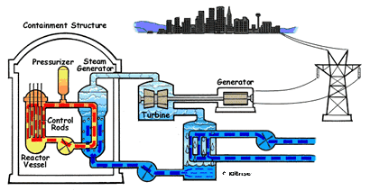
Electric generator
Condenser
Nuclear Reactor
Steam

Nuclear Power Plants

(Energy Output)
(Energy Input)
(Matter Input)
(Matter Output)

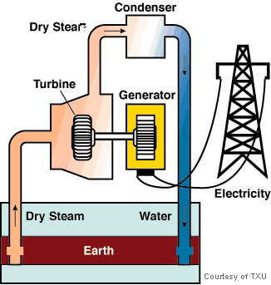
Geothermal Power Plant

(Energy Output)
(Energy Input)
(Matter Input)
(Matter Output)
Steam

3. Solar cells have the same function as electric generators – they can generate electricity. When the light hits on the solar cells, an unobservable change will happen and electricity is generated.

Solar Power Plant

(Energy Output)
(Energy Input)
(Matter Input)
(Matter Output)

Part 2. All Working together

At home, we use a lot of electric appliances such as lamps, computers, toasters, refrigerators, and so on. All of these electric appliances require electricity to work. The diagram below shows where the electricity comes from. Please label the energy arrows and matter arrows.
Solar Power Plant
Wind Power Plant
Nuclear Power Plant
Coal-fired Power Plant

Electricity Grid
Hydropower Plant
Geothermal Power Plant
Using Electric Appliances at Home

2. Study the above diagrams and answer the following questions.

1) What patterns in energy movement do you see in the diagram?

2) Think about all the things we use that need energy. Why do you think we need a constant energy supply from our environment in order to keep these things running?

3) Look at all the different ways we generate power for our homes. Which power plant is different from all the others, and how is it different?

When each power plant works, only part of the energy input transforms into electrical energy. The remaining energy is lost into the environment as heat. Some power plants are more efficient, which means they experience less heat loss. For example, hydropower plants can transform about 85% of the gravitational energy of water into electrical energy. Some are not efficient. For example, solar power plants can only transform 30% of light energy into electrical energy; wind power plants can only transform 15% - 20% of motion energy into electrical energy. The most common power plants we use in the US are coal-fired power plants. They generate more than half of our electricity. They can transform about 30% to 40% chemical energy of coals into electrical energy.
Do you know?

WHERE DO FOSSIL FUELS COME FROM?

Fossil fuels are formed over many millions of years from the remains of plants and animals. In this activity you will use the process tool to analyze how matter and energy transform in the process of fossil fuel formation.

PETROLEUM AND NATURAL GAS FORMATION
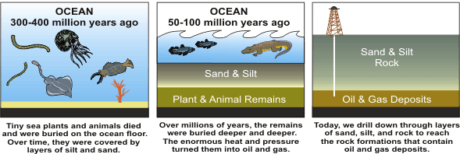

Oil (petroleum) and natural gas are formed from the remains of animals and plants that lived millions of years ago in a marine (water) environment before the dinosaurs. Over the years, the remains were covered by layers of mud. Heat and pressure from these layers helped the remains turn into what we today call crude oil. The word "petroleum" means "rock oil" or "oil from the earth." Oil and natural gas are composed of carbon and hydrogen atoms.

COAL FORMATION

Coal was formed in a similar way, mainly from the plants that lived hundreds of millions of years ago, when the earth was partly covered with swampy forests. Layers of dead plants were covered by layers of water and dirt. The heat and pressure from the top layers helped the plant remains turn into what we today call coal. Coal is composed primarily of carbon, hydrogen, and oxygen atoms.
Name: _________________________________________ Date: _________________

You have read about how fossil fuels form. Using the process tool, describe how the event of fossil fuel formation changes matter and how it changes energy. Complete the process tool for Coal Formation and for Oil and Natural Gas Formation.

Coal Formation

(Energy Output)
(Energy Input)
(Matter Input)
(Matter Output)

Oil and Natural Gas Formation

(Energy Output)
(Energy Input)
(Matter Input)
(Matter Output)

Name: _______________________________________ Date: ________________

Foods, Fuels, and Body Parts: How are They Similar?

1. The foods we eat are from plants and animals. All animals feed directly or indirectly on plants. So, the major materials of foods and body parts of plants and animals are similar. Below are two examples of molecules contained in plant and animal body structure.

A Glucose Molecule from Plant Body Structure

A fat Molecule from Animal Body Structure

Please compare the molecule of plant body and the molecule of the animal body. How are they similar?

2. Wood, propane, coals, wax, gasoline are fuels. Fuels are changed from plants or animals. Wood is from trees. Coals are changed from residues of plants that lived on earth millions of years ago. Propane, wax, and gasoline are made from oil. Oil is changed from residues of sea creatures that lived millions of years ago. Below are two examples of fuel molecules.

An octane molecule (C₈H₁₈) from gasoline

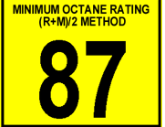

A propane molecule (C₃H₈)

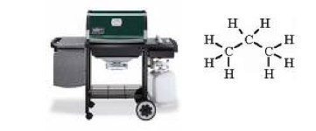

2. Please compare the two fuel molecules. How are they similar?

3. Please compare the four molecules. How are they similar?

4. Foods, fuels, and organism body parts are composed of similar materials – organic materials. These organic materials have similar molecular structure—they all contain C-C and C-H bonds. In science, this indicates that the organic materials contain chemical energy and can release energy when they react with oxygen. In particular, organic materials can burn because they contain chemical energy. In the process of burning, their chemical energy is transformed into other forms of energy such as heat, light energy, or motion energy. Below are some materials. Are they organic materials? Can flame burn each of them? Circle all the materials that can burn.

Gasoline Sand Coal Peanut

Methane Flour Paper Milk Powder

Water Wood Wax Stone

How are the materials you circled similar? How do you know that they can burn?

Name:__________________________ Period/Hour:________

CONNECTING PROCESSES
Part 1. Connecting Processes

You have learned how to use the process tool to analyze individual events, or processes. In the following questions, you will need to use the process tool to represent how matter and energy move across multiple processes. This means you will use the process tool to describe how several events are connected to each other.

- The process box has a label of macroscopic event or process. It also shows the atomic-molecular process if it is involved.
- The energy arrow is wavy and has a label showing the energy form.
- The matter arrow is straight and has a label showing the materials involved (“Org” represents organic carbon-containing materials, like foods, fuels, and organisms body parts).

The process boxes are connected by the matter arrows and energy arrows, which means that part of the matter/energy output of one process could be the matter/energy input of the next process.

Broccoli
Growth

Girl Running
CE

Plant Body

O_{2_}

ME

LE

CO₂

H₂O

___ Heat____

___ Heat_______

Look at the example on the right.

What pattern do you notice about how matter moves?

What pattern do you notice about how energy moves?

1. Now it’s your turn to fill in the process tools. The diagram below shows a sequence of three processes: ancient plant growth, ancient animal growth, oil formation, and car running on gasoline. Think about how these are connected and how matter and energy move between each process.

Label the matter arrows and the energy arrows by filling in all of the blanks.

Oil Formation

___ _______

Car Running on Gasoline

CO₂ + H₂O

___ _______

Ancient Sea Animal
Growth

___ _______

Ancient Plant
Growth

CO₂ + H₂O

O₂
___ _______

O₂

2. The sequence below will help you understand how matter and energy change when your family are watching TV at night. The diagram below shows one way of generating energy to power the television. Some matter and energy arrows are miss labels. Please label them.
Watching TV at Home
Coal Formation

Heat

O₂

O₂

CO₂ + H₂O

CO₂ + H₂O

Heat

Heat

Coal-fired Power Plant

Heat

Plant Growth
Heat

LE

2. Where does the electrical energy come from? Please use the table above to explain where the electrical energy that powers your house comes from.

3. Do you think using electricity will cause carbon dioxide emissions? If your answer is yes, how is carbon dioxide emitted?

4. Do you think all electricity generation will emit CO2? Why?

5. Compare the pattern of matter movement with the pattern of energy movement. How are they different?

Carbon Dioxide and Global Warming

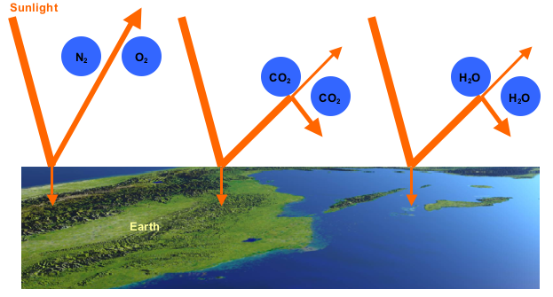

You have probably heard the idea of global warming a lot in the news lately, but do you know the main cause of global warming? Global warming is mainly caused by greenhouse gases in the air. In the System and Scales Unit, you learned that air is a mixture of four key gases—CO₂, H₂O, O₂, N₂. Among them are two greenhouse gases—CO₂ and H₂O. When sunlight reaches the earth, it is reflected back from the earth’s surface, but the reflection causes a change in the light’s wavelength (it lengthens it). The greenhouse gases (carbon dioxide and water vapor) are able to catch the reflected sunlight and prevent them from escaping into the space. As a result, the light’s energy is trapped, leading to a warmer atmosphere.

Knowing where carbon dioxide is going is important for understanding global warming.

Scientists use carbon cycling models to explain how carbon dioxide moves in and out of atmosphere over time. Below is an example.

Carbon Dioxide Movement: Carbon dioxide movement is about the processes that move carbon dioxide in and out of the atmosphere. It contains two types of processes: ones that take carbon dioxide in (or absorb it) and ones that give carbon dioxide off (or emit it).
- Carbon dioxide given off (blue arrows) –Both natural processes and human activities give off carbon dioxide into the atmosphere. One example of this is the ocean releasing carbon dioxide into the atmosphere when the temperature is relatively high. There are also biological and chemical processes that give off carbon dioxide into the atmosphere. Do you know what those processes are?
- Carbon dioxide taken in (green arrows) – Scientists have invented new technology to remove carbon dioxide from the atmosphere. One example of this is carbon dioxide being dissolved into the surface of oceans. There is also an important biological process that removes carbon dioxide from the atmosphere. Do you know what the process is?

Carbon Reservoir: Carbon exists in several reservoirs in different forms.
- Atmosphere carbon reservoir
- Biosphere carbon reservoir
- Fossil fuel carbon reservoir
- Ocean carbon reservoir
Atmosphere Carbon Reservoir
Ocean Carbon Reservoir
Fossil Fuel Carbon Reservoir
Biosphere Carbon Reservoir
(Plants, Soil)
Fossil-fuel Burning
Plant/Animal Respiration

Plant Photosynthesis
Change of Land Use
Ocean Uptake of CO₂
Ocean Release of CO₂
Decay of Residues
Arrows: Carbon Fluxes

Name: _________________________________________ Date: ________________

Analyze the Model of Carbon Cycling

1. Use the process tool to analyze the biological and chemical processes labeled in the diagram. You will need to figure out the missing parts that would fill in the blanks in the process tool and fill them in the table below.

Macroscopic Process/Event:
________________________
Atomic-molecular Process:
__________________________
Matter Input:

Energy Input:

Matter Output:

Energy Output:

Process/Event from the diagram | Atomic-molecular Process | Energy Input | Energy Output | Matter Input | Matter Output
Fossil-fuel burning
Plant photosynthesis
Plant respiration
Decay of residue

2. What is the form of carbon in the atmosphere? ____________________________________

3. What is the form of carbon in the biosphere? ______________________________________

4. What is the form of carbon in the fossil fuel reservoir? _______________________________

5. Please explain how change of land uses such as deforestation causes carbon dioxide moving into the atmosphere? What is the relevant atomic-molecular process?
Name:__________________________________ Period/Hour:________

Analyze News Reports from Media

Below are news reports about three events happening in different regions around the world. Please explain whether and how these events will influence global warming. You will first need to use the process tool to analyze the event and then answer the questions based on your analysis.

1. DEFORESTATION IN BRAZIL: 60-70 percent of deforestation in the Amazon results from cattle ranches while the rest mostly results from small-scale subsistence agriculture. Despite the widespread press attention, large-scale farming (i.e. soybeans) currently contributes relatively little to total deforestation in the Amazon. Most soybean cultivation takes place outside the rainforest in the neighboring cerrado grassland ecosystem and in areas that have already been cleared. Logging results in forest degradation but rarely direct deforestation. However, studies have showed a close correlation between logging and future clearing for settlement and farming.

Please use the process tool to analyze how trees growing in the Amazon Forest changes matter and energy.
Macroscopic Process/Event:

Deforestation in the Amazon Rain Forest
Atomic-molecular Process:

__________________________
Matter Input:

Energy Input:

Matter Output:

Energy Output:

Now look at your process tool diagram. Think about whether this process takes in or gives off carbon dioxide. Then explain how the event will influence global warming:

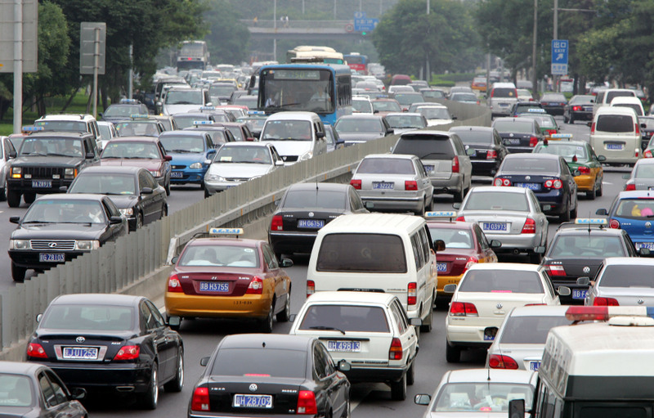
- Beijing, China: General Motors has estimated that China sold 790,000 vehicles in January, surpassing the United States, where sales tumbled 37 percent from a year ago to 656,976 vehicles. The leading US automaker further predicts that Chinese auto sales could hit 10.7 million vehicles this year, nearly a million units more than its estimate of 9.8 million for the same period in the US. Although auto sales have slowed in recent months, China remains the world's only major auto market with strong potential given strong domestic demand and recent government policies. The government passed a stimulus package for the auto sector last month, reducing the purchase tax on vehicles with engine capacity of less than 1.6 liters by half, to 5 percent. It is also spending RMB 5 billion on subsidies to rural residents who trade in old vehicles for vehicles 1.3 liters or less.
Macroscopic Process/Event:

China Becoming the World’s Second Largest Auto Market
Atomic-molecular Process:

__________________________
Matter Input:

Energy Input:

Matter Output:

Energy Output:

Think about your process tool and explain how this event may influence global warming.

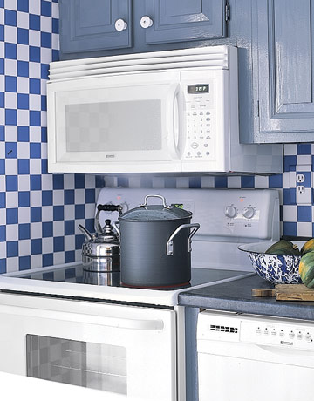
3. US, Washington – In 1978, only eight percent of U.S. households had microwave ovens. Today, 83 percent have them. According to the U.S. Energy Information Administration, electricity consumption will increase by 51 percent from 2002 to 2025. At present about half electricity in US comes from burning coals.

Macroscopic Process/Event:

Increase of the Consumption of Electricity in US
Atomic-molecular Process:

__________________________
Matter Input:

Energy Input:

Matter Output:

Energy Output:

Please explain how the event will influence global warming:

4. How do humans’ activities of consuming foods and fuels influence the amount of carbon dioxide in the atmosphere?

5. Explain why humans largely relies on plants for survival. Please explain chemical processes that we depend on for survival

Name:__________________________ Period/Hour:________

CARBON FOOTPRINT (DAY 1)

Part 1. What is Carbon Footprint?
Carbon footprint measures the amount of CO₂ emission caused by energy consuming activities. In our everyday life, some processes emit carbon dioxide directly. For example, when a car is running, it produces CO₂ by burning gasoline. But sometime, measuring carbon emission could be very complicated. For example, to measure the amount of CO₂ released when eating a piece of bread, you will need to calculate the total amount of CO₂ emitted over the full life cycle of the bread including growing wheat, transportation of raw materials, packaging, food processing, distribution, disposal, etc.

The average American produces 20 tons of CO₂ each year through their day-to-day activities. Below are some data about American’s carbon footprint:
- Heat and cooling the average American home of a family of four: 15 tons of CO₂
- Driving one car for one year: 6 tons of CO₂
- Food consumption for a family of four: 2.6 tons of CO₂
- One round trip flight from Philadelphia to San Francisco: 1 ton of CO₂
- One person’s share of public services: 1.5 tons of CO₂ (This refers to the public services of your city township, such as street lights, road repair and maintenance, trash removal, etc.)
A ton equals 1000 Kilograms. It is about 2,000 lbs. That means that if each student weighs 100 pounds, it will take 20 students to make a ton. (100 x 20 = 2,000).

Do you know?
Part 2. Measuring Carbon Footprint – A Michigan Family
A family of three living in Michigan creates 50.8 tons of carbon in the year of 2008. The picture below shows the breakdown of the carbon footprint that family. Please choose two components of the family’s footprint and explain how it provides energy for the family’s daily activities and why the consumption of energy causes carbon emission.

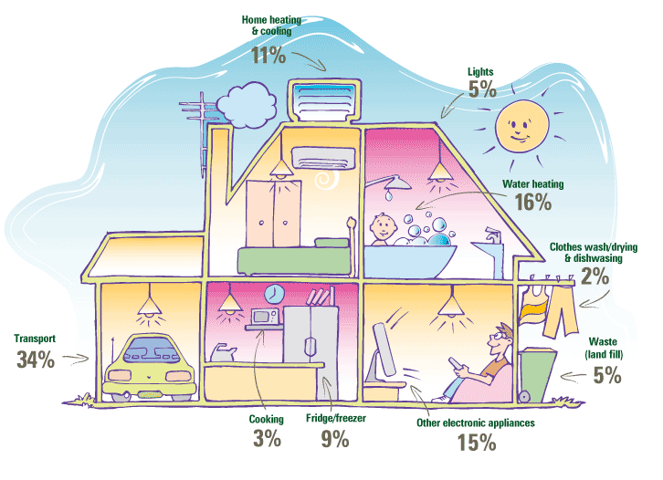

Name:__________________________ Period/Hour:________

CARBON FOOTPRINT (DAY 2)

Part 2. Measuring Carbon Footprint – A Bag of Sugar
Silver spoon is a sugar manufacturer that measures the carbon footprint of its sugar products. The carbon footprint of a product considers the product’s total life cycle from ‘field to fork’. According to the company’ assessment, a one kg bag of homegrown sugar produces 0.5 kg of CO₂. The diagram below shows the percentage of the carbon emission at each stage of the life cycle of a bag of homegrown sugar.

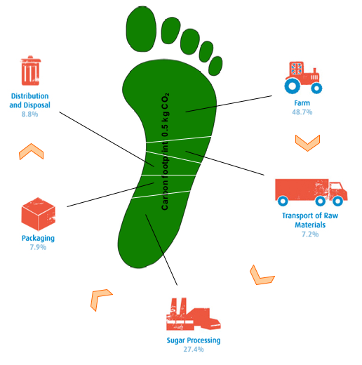
Please use the process tool to analyze how carbon dioxide is emitted at each stage of the life cycle of a one kg bag of homegrown sugar. You will need to fill out the missing parts in the blanks in the process tool. (Use OrgC to represent Organic carbon-containing substances.)

Stage 1. Farming (48.7%):
Cultivation of crops results in CO2 emission during the production of seeds, fertilizers, pesticides and soil amendments, operation of farm equipment, etc. Please use the process tool to explain how the following two processes emit CO2 into the atmosphere: Operation of farm equipment such as using electricity powered irrigation systems; Beet respiration

Macroscopic Process/Event:

Operation of farm equipment
Atomic-molecular Process:

__________________________
Matter Input:

Energy Input:

Matter Output:

Energy Output:

Macroscopic Process/Event:

Beet Respiration
Atomic-molecular Process:

_____________________
Matter Input:

Energy Input:

Matter Output:

Energy Output:

Stage 2. Transportation of raw materials (7.2%):
The raw materials—beets need to be shipped to the factory for sugar production. Please use the process tool to analyze how transportation release carbon dioxide.
Macroscopic Process/Event:

Transportation of raw materials
Atomic-molecular Process:

__________________________
Matter Input:

Energy Input:

Matter Output:

Energy Output:

Stage 3. Sugar processing (27.4%):
At this stage, the factory uses machines to make sugar out of beets. Do you think using machines to produce sugar will cause carbon emission? Please fill out the blanks in the process tool.

Macroscopic Process/Event:

Sugar Processing
Atomic-molecular Process:

__________________________
Matter Input:

Energy Input:

Matter Output:

Energy Output:

Stage 4. Packaging (7.9%):
Carbon dioxide is emitted during the production and transportation of the packaging materials as well as the process of packaging in the assembly line. Please use the process tool to analyze why the packaging sugar at the end of the assembly line cause carbon emission.
Macroscopic Process/Event:

Packaging sugar at the end of the assembly line

Atomic-molecular Process:

__________________________
Matter Input:

Energy Input:

Matter Output:

Energy Output:

Stage 5. Distribution and disposal (8.8%):

Distribution: Distribution of products refers to shipping materials to the supermarkets or grocery stores.
Disposal: Packaging materials will eventually become waste. Carbon is emitted when the waste is transported to the waste disposal site or factories. The waste could be either land-filled or recycled. When the organic waste (such as paper bag) is land-filled, decomposition will happen and release carbon dioxide. Recycling can save energy, as it is generally more energy efficient to manufacture products using recycled inputs instead of raw materials. Please use the process tool to analyze one of the processes related to distribution and disposal: Organic waste decaying at the waste disposal site.

Macroscopic Process/Event:

Organic waste decaying at the waste disposal site

Atomic-molecular Process:

_________________________
Matter Input:

Energy Input:

Matter Output:

Energy Output:

CARBON FOOTPRINT IN DIFFERENT COUNTRIES

Read the following stories about students’ lives in different regions of the world and make predictions about the size of their carbon footprints. Then answer the questions.

Argentina - Nahual
It is 7:30 am, and time for 17-year-old Nahual to get up for school. He lives in Salta, a city in Argentina with 469,000 residents. His family’s row house is on a busy street, and although it is
small, 112 square meters for the five of them, it has running water and electricity. Sometimes he fights with his two younger sisters about sharing the bathroom, but his parents say that he should be more mature now that he is finishing high school.

At lunchtime, he walks home to eat the main meal of the day. He especially likes barbeque, pasta, and pizza. Nahual and his family have meat every day and about three-quarters of their food is processed or packaged. After lunch, he has a siesta and does something relaxing before walking back to class. At 5 pm they have a quick teatime when everyone drinks “mate,” which is a bitter tea. Nahual’s favorite part of the day is the evening when he plays soccer with his sports club.

On Fridays, Nahual likes to hang out with his friends and have pizza, and on Saturdays they often go dance. Like most families, Nahual’s family has one car that uses 8 liters per 100 kilometers. Because he is too young to drive, Nahual often takes the bus. He travels about 55 km a week using public transportation. Each Sunday his family drives 14 kilometers roundtrip to church. After church, Nahual’s family gets together for “asado,” or barbeque. All the grandparents and aunts and uncles come too. Afterwards they walk to the park for ice cream, then Nahual has to hurry home and finish his homework for school on Monday.

China - Wu Dong
It is a warm morning in Shiping, Yunan, China, as 15-year old Wu Dong bikes to school in his town of 169,000 people with a climate similar to Chengdu. Biking is the most common form of transportation. Most of the time, Wu Dong walks or bikes everywhere he goes, except on Saturday when he makes a 30 km round trip with his mother on the bus to the large market. They buy foods such as rice and oil that the family doesn’t grow themselves. His family grows tomatoes, cabbage, squash and cucumbers in their courtyard kitchen garden and grapes on a trellis, so only about one quarter of the family food is processed and not produced locally.

Wu Dong’s home sits on the edge of a brook, which feeds through a gate into the pond where the family raises fish. Wu Dong lives with his parents, two of his grandparents, his aunt and uncle, and their newborn baby girl in their 55 square meter house. Although his family home has electricity, it does not have running water. When he has finished his homework, he likes to watch TV with his family, but he usually stays very busy with homework and helping with chores. Wu Dong’s family works hard but they also have a good time.

Everyday his mother spends a long time preparing food from raw ingredients, and today for lunch his mother has prepared soup made from tofu and cabbage, along with lotus root, fish, cooked celery, two types of beans, hot sauce and rice. The family has meat about twice a week, and Wu Dong looks forward to these extra special meals.

US – Jessica
Jessica studies at York Comm High School in Elmhurst, Illinois, US, which is only a short bicycle ride away from her home. If she has free time during the week, Jessica likes to see friends or visit the shops, always traveling on her bicycle. On Sundays, Jessica and her family often go to a nearby church, where they meet their friends. They always have a good time there. Jessica’s parents sometimes invite their friends to have dinner at their house. They always use

Jessica, her little sister, and her parents live in a four-bedroom house. It is 185 square meters (1,992 square feet). Her home has running water and electricity. Jessica’s mom recently changed all the light bulbs into fluorescent light bulbs. She told Jessica that a fluorescent bulb uses 75% less energy than an incandescent bulb. Illinois is very cold during the winter and Jessica’s house is a bit old, so they have to use a lot of electricity for heating in the winter. Jessica’s family always tries to use electricity efficiently, as do all of the homes in the neighborhood.

Elmhurst has a population of 43,000 and is only a 30-minute drive from Chicago where they sometimes go to visit her aunt. On average she travels 100 km a week in her family car, which is a hybrid car and consumes 4.9 liters of gas per 100 km.

In the evening, Jessica and her family have dinner together. Their dinner usually consists of a pasta course, followed by a main course of meat or fish. Sometimes a course of dissert is served at the end. The dissert may be ice cream or yogurt. Jessica’s mom likes to buy fresh food at Meijer and Kroger’s. She has bought several reusable bags. When she was shopping, she always uses those reusable bags instead of the plastic or paper bags provided by the supermarket. About half of the food Jessica eats is packaged and not locally grown.

Mexico - Carmen
Carmen is 16 years old. She lives in Cuernavaca, Mexico with her parents and two brothers. It is a big city with 705,000 people. It is only 50 miles from Mexico City. A large majority of people in Mexico lives in urban areas, and most of Carmen’s relatives live in cities.

Their house is small, about 65 square meters, but they have running water and electricity, and a small yard. Carmen ’s parents have turned part of their house into a changarro – a mini convenience store. At first they only carried a few items in their little store like pork rinds, sausages, candies, Coca-Cola and delicious foods. Now they are increasing their selection, and have even hung a television from the ceiling to help pass the time. Carmen is often left in charge of the shop in the evenings, or during the day on the weekends. Carmen’s parents sometimes have party at home. Her mom always needs to prepare enough paper tissues, cups, and plates for the parties.

Carmen likes to watch the soap operas on TV when it is her turn to work in the shop. Carmen and her family love to eat chips, candy, and other snack foods. Roughly three quarters of their food is processed or packaged. In an average week, the family drinks more than 20 quarts of Coca-Cola. Mexico is the number one consumer of Coca-Cola in the world. Carmen also eats tamales, cheese enchiladas, quesadillas, beans and rice and lots of tortillas. Carmen’s mother is a great cook, and the family has meat or eggs every day. Tortillas, made of corn, are eaten with every meal. When Carmen’s family goes out shopping they either walk or take the bus. Carmen usually walks or rides her bike to run errands for her mother and to visit her friends. Carmen’s grandmother, who is elderly and frail, lives in Mexico City, and Carmen and her mother travel on the bus twice a week to see her. On average Carmen travels 270 km a week using public transportation.
South Africa - Wisani
Wisani lives in Soweto, South Africa with her parents, sister and two brothers. She is 15 years old. There are many young people living in Soweto. In fact, 25 percent of the population is under 15 years of age. Soweto has more than a million people and is larger than the nearby city of Johannesburg. Wisani’s school is in Johannesburg. Her dad has a long drive to work, and he drops Wisani at school on the way. She rides the bus home 30 kilometers from school each day. Wisani and her family drive up to 280 km in their car each week. Their car is old and in poor condition, using over 15 liters of gasoline per 100 kilometers. Wisani also uses public transport such as buses and kombis (minibuses) for about 50 kilometers of travel each week when she runs errands to the shops and visits with her friends in Soweto.

Her family owns a small house (65 square meters), which has electricity and running water. Every house in the street looks very similar. The neighbor’s houses are very close to theirs, and the street is narrow. Wisani’s family stays inside their home after 8:00 pm and locks the doors because of the high rate of crime and violence. For the same reason, Wisani seldom walks or rides her bike. The area where they live is heavily populated, so almost all their food is grown or produced in other areas of South Africa. The most common meal for Wisani’s family is mealies, or maize, which is made into porridge. They also regularly eat some fruits and vegetables, and eat cheaper cuts of meat at least once a day. They drink tea with their meals, and her dad sometimes buys homemade beer from one of the neighbors. Almost all their food is unprocessed, but it has to be transported a long way before they receive it. This has about the same impact as using 3/4 of processed food.
Wisani and her whole family travel by plane once a year for a visit to her grandparents, who live in Cape Town. The flights take about 3 hours total. It is a big expense for the family, and they save for the trip all year.

1. Compare Wu Dong’s meal, Carmen’s meal, and Wisani’s meal. Please explain how the food each of them eats contributes to the size of his/her carbon footprint.

2. Compare the trash bins in Jessica’s house and Carmen’s house. Explain how the goods each student consumes contribute to the size of his/her footprint.

3. Compare Jessica’s transportation with Wisani’s transportation. Explain how the transportation contributes to the size of his/her footprint?

4. Compare the size of each student’s house. Who has the largest house? How does the size of the student’s house contribute to the size of his/her footprint?

5. Compare how Jessica and Carmen use electricity at home. Explain how the way each student uses the electrical appliances contributes to the size of his/her footprint.

Take Actions

Questions:

1. You have two meal choices for your lunch at school: 1) chicken and veggie wrap, mashed potatoes, and an apple; 2) beef hamburger, potato chips, and a box of orange juice. These two meals provide similar amount of energy for your body.
Which meal will have a smaller carbon footprint? Why?

Which meal will you choose? Why?

2. It is a beautiful sunny day in spring. Your dad can choose between three ways of commuting to his office: 1) riding bicycle; 2) taking bus; 3) driving his car.
Which choice will result in the largest carbon footprint? Which choice will result in the smallest carbon footprint? Why?

Will you recommend the one that has the smallest footprint to your dad? Why?

3. Your mom would like to buy some oranges. There are two stores near your home. One is a supermarket that sells organs made in California. The other is a grocery store, which sells oranges produced by local farmers here in Michigan. Compare the footprint of an orange sold in the supermarket and the footprint of an orange sold in the grocery store. Which one would result in a smaller carbon footprint? Why?

Will you suggest your mom to buy oranges with a smaller carbon footprint? Why?

